**Waiting Port Assignment**

**Task: - Waiting Port Assignment** is a task which stuck in the workflow when one of the condition out of three is not satisfied.

Three conditions to check Waiting Port Assignment are:

1. ASGN
2. PAID
3. Order segmented in ICORE or not.

Follow below steps to check all the conditions:

1. Check the order in the GUI and DB for ready tasks.

**Inconcert Query used:**

Select ord.purge_IND,ms.ms_task_id,ord.usrp_order_number,sub.order_gate1_status, sub.ms_sub_order_id,sub.wan_link_ip_addr, wf.name, wf.status, wf.job_id, wf.task_id, wf.first_ready_time,wf.ready_time, wf.due_date, wf.done_time, wf.first_ready_time,wf.skipped_time, wf.perform_condition, wf.ITERATE_CONDITION

from ms_order ord, ms_sub_order sub,ms_job j,wf_task wf,wf_job job,ms_task ms

where

Ord.Usrp_Order_Number In

('157512824')and ord.ms_order_id = sub.ms_order_id and ms_sub_order_id = j.entity_id

and wf.job_id= hextoraw(j.wf_job_id) And Wf.Job_Id = Job.Job_Id and wf.task_id= ms.WF_TASK_ID

and j.entity_type=5 and (wf.status in (1));

**mS Updates SQL Query:-**

SELECT usrp_order_number, o.ms_order_id, ms_sub_order_id, t.name, t.status_updated_date , t.status, t.* FROM ms_task t, ms_job j, ms_order o , ms_sub_order so WHERE usrp_order_number IN ( '194943727' ) AND so.ms_order_id = o.ms_order_id AND entity_id = ms_sub_order_id AND entity_type = 5 AND t.wf_job_id = j.wf_job_id and t.status = 1;

New Query mS

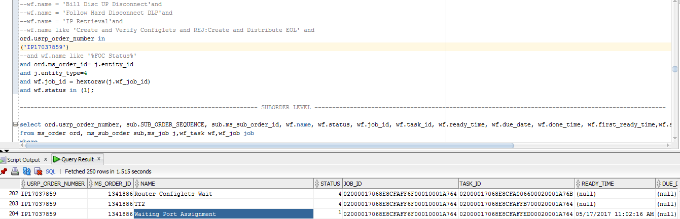

**EFMS GUI** [**URL :-**](URL:-)

[**http://efmsms.it.att.com:8008/MS**](http://efmsms.it.att.com:8008/MS)

**EFMS GUI:**

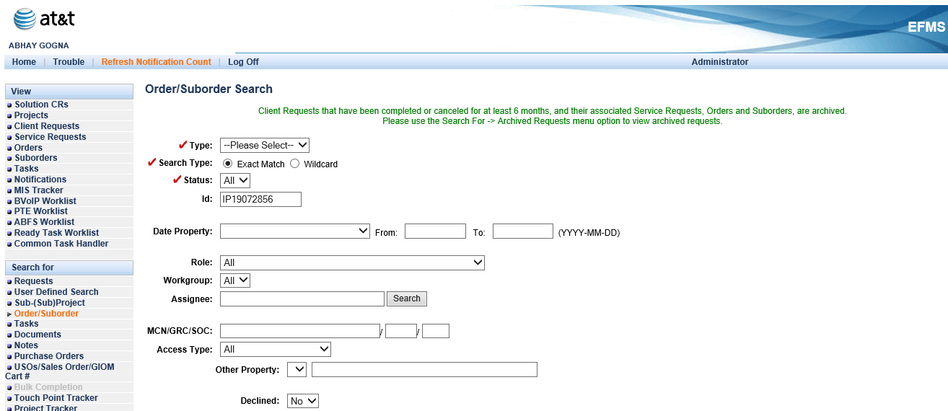

**Order / Sub-Order Level:**

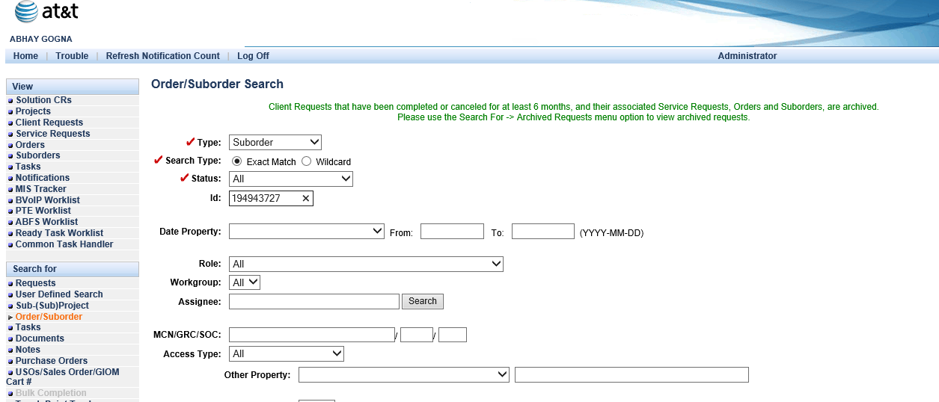

**Task List:**

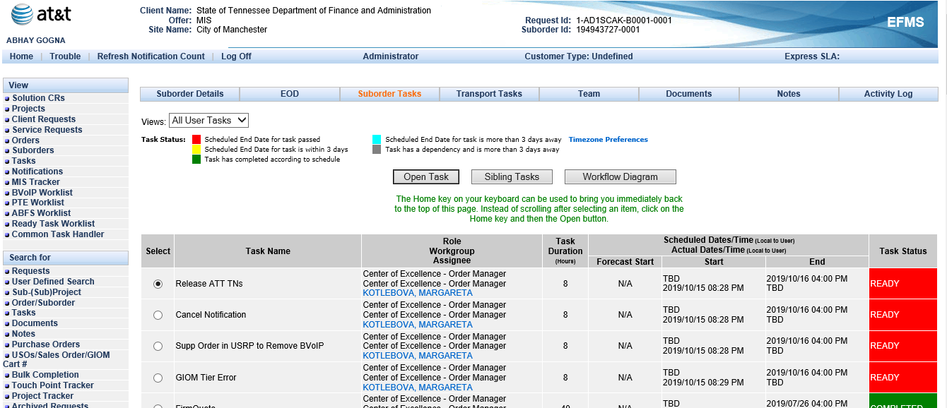

1. To check if PAID is present or not - Run below SQL query:

select PORT_ASSIGNMENT_ID from ms_sub_order where MS_ORDER_ID in (select ms_order_id from ms_order where usrp_order_number = 'IP14057102');

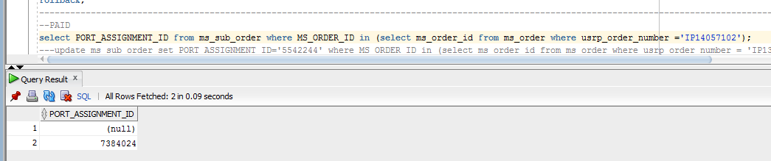

In above screen shot, PAID is present in EFMS.

1. To check ASGN: In the EFMS-GUI, check whether the "ASGN" event in EFMS-A completed.
2. Open order in EFMS GUI, Go to Order details then select USO status tab. Hit Search.

URL Link:-

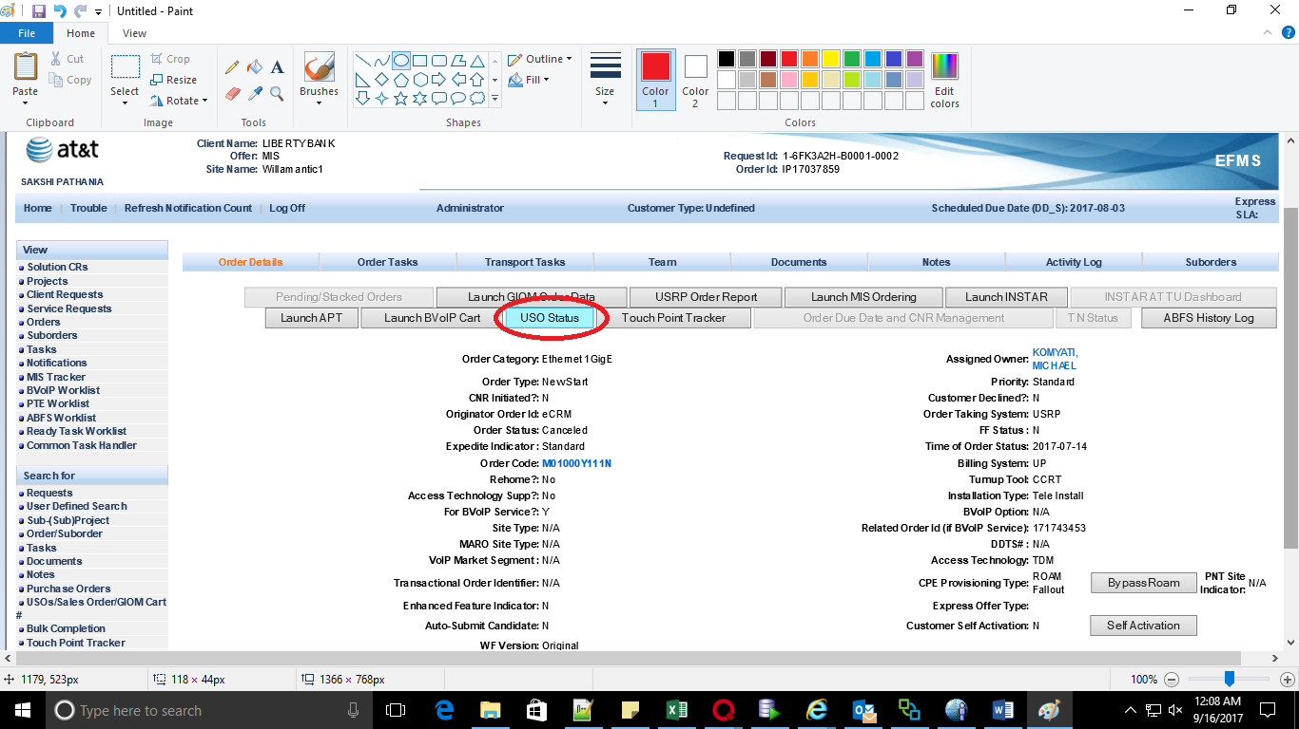

1. Click on Search button without any inputs in any of the field.
2. Click on the hyperlink for USO# for each sub-order as show below:

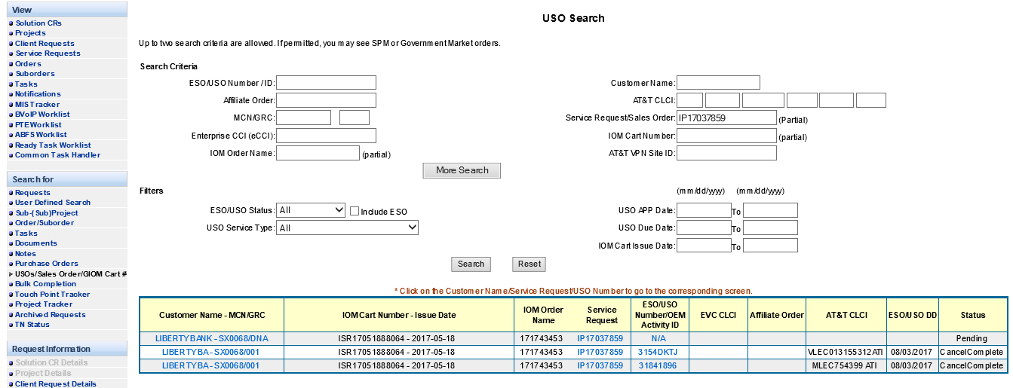

1. Confirm that the ASGN is completed on the both USO.

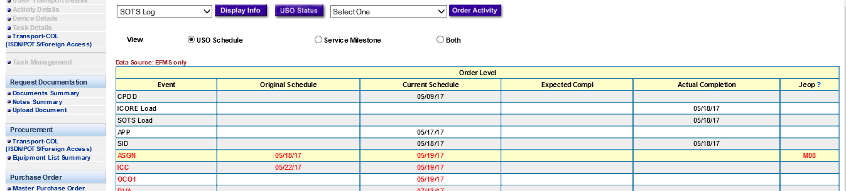

Actual Complete date should be populated, that’s indicates the completion of the event.

In above screen shot, it’s not completed.

**Note:**

We can also check ASGN from below queries in EFMS-A:

select o.order_number,o.svc_order_id ,o.status from svc_request s, svc_order o where s.svc_request_name in('IP14101512') and s.svc_request_id = o.svc_request_id and (o.status = 0 or o.status = 1 or o.status =4 );

--Put the Svc_order_id from above query in below script:

select svc_order_id, EVENT_ID, event_type, COMPLETED_DATE, COMPLETED_DATE_STAMP, NOTE from event where SVC_ORDER_ID in ('232382627','232382628','232439759’) and event_type='45';

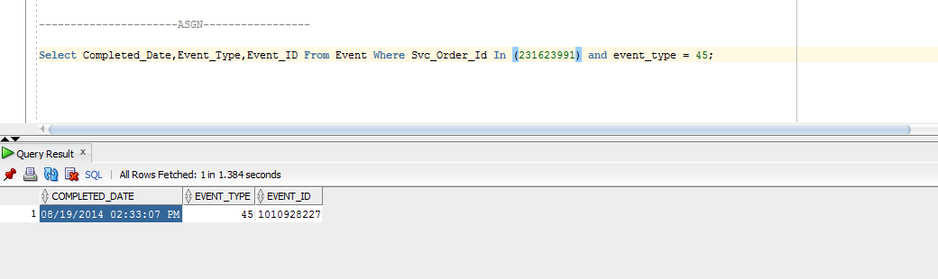

At least for one USO ASGN should be completed.

If ASGN is not completed for all USO's then create a ticket to EFMS-A to find out why ASGN not completed for related USO.

4. If the completion date is NULL, so that may be the reason you see the task in workflow stuck. In order for the ASGN to complete, the order needs to be segmented in ICORE, you can check with INSTAR team to see if it has.

5. If the order has not segmented in ICORE, then this will go back to the user as the order has not segmented. This could be due to the order not loading properly in ICORE, etc. but there is nothing we can do if this has not segmented. User should find out why the order did not segment in ICORE. The key thing to remember is we cannot progress this unless it has segmented.

6. If segmented, fc the Waiting Port Assignment task. Sometimes you will see two other tasks in workflow that go along with the port assignment task. If you see these, you FC them as well.

They are:

--and wf.name like 'Port Assignment USRPIP Update Fallout'

--and wf.name like 'Wait for USRP Paired Message'

If all of the three conditions are met, we can Fc the Waiting Port Assignment task:

* Pick the Task Id of the task



- Use following commands in Putty:

- cd complete

- fc.run and enter the task id.

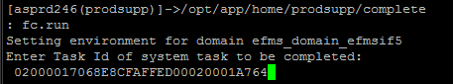

After completion, you can see the task in Completed state in EFMS GUI:



7. If you have reports the order has not segmented, you can say to user:

User,

Order has not segmented in ICORE and workflow cannot progress until this has happened. Please ensure order has loaded to ICORE properly so that it may segment. EFMS PSO cannot progress the workflow until the order has segmented in ICORE.